July 2015
Answering Questions with PivotTables
Jessica Joy Morris
Manager of Instructional Data
DC Public Schools

jjmorrisdc@gmail.com

Steps for Investigating Questions with PivotTables

Overview
At least two or three times of year, it is a good idea to meet with your leadership team to review your school data and then develop priority questions that can be investigated further.

Once you identify these questions, one way to answer them is to get more data by requesting or putting together a dataset and using PivotTables to investigate the questions further. Then your team can generate data-driven solutions.

Steps for generating and investigating priority questions
- Allocate a 90-120 minute leadership meeting to review summary data from your school to find areas you are concerned about. For example, you might consider:
  - Attendance
  - Behavior
  - Performance
  - Demographics
  - Enrollment
Note: For any of these, you could look at one point in time or at two points in time (BOY/EOY)
- Identify several data points you are concerned about.
- Select one of these data points you are most interested in investigating. Write a question about your area of concern.
One basic format for the question could be:
What (school/student/teacher) characteristics
may be related to (area of concern)?
A more advanced format for the question could be:
How did (area of concern) change over time for
(students/teachers) with certain student characteristics?
- Brainstorm student characteristics that could be contributing to this condition.
- Identify what data you would need to examine these characteristics
- Request or put together a data set with this data
- Analyze the data with PivotTables
- Generate data-driven solutions

Example Inquiry Process
- After investigating my schools data, my team selected the following area of concern:

I am reviewing data from this past school year and
found that year-to-date in-seat attendance was 90%
- Together, my leadership team generated the following priority question:

What demographic and classroom characteristics may be related to attendance?

- My leadership team then brainstormed student characteristics that could be related to attendance:

  - Grade and teacher
  - Gender
  - Low performance
  - Special education status
  - Behavior
  - Out-of-boundary status
  - Homelessness
  - Prior attendance
  - Student safety
- One member of my leadership team discussed with the manager of our data warehouse which characteristics we could actually look at. We had to cross off certain questions because of the available data.

- Together, we put together the following data set:

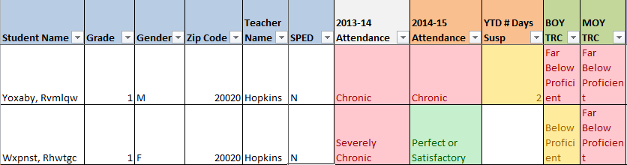

Analysis with PivotTables
Overview: Using the table and what you have learned about creating PivotTables, you will now investigate the question with PivotTables

Example Inquiry Process with a PivotTable

Characteristic: Gender

PivotTable 1:
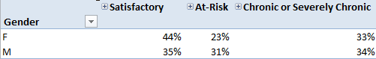

Analysis: There is a gap in attendance by gender

PivotTable 2:
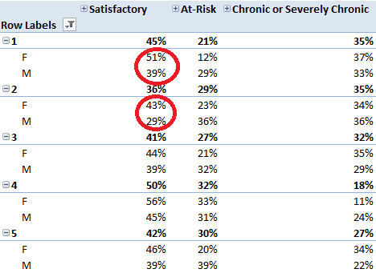

Analysis: The gender gap is most pronounced in 1st and 2nd grade

PivotTable 3:

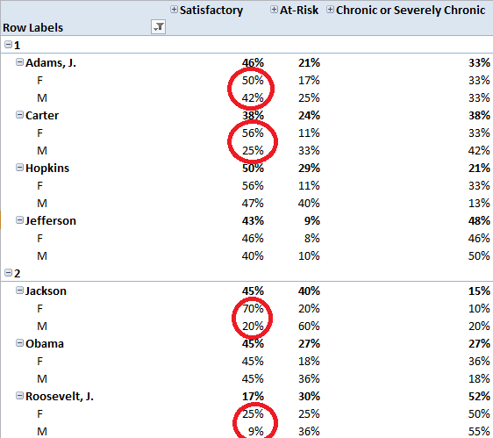

Analysis:
- The gender gap in attendance is most pronounced in the following classes: J. Adams, Carter, Jackson, and Roosevelt

Question:
- Is there any difference in how males are treated in these four classrooms, compared with my other first and second grade classes?

Next Steps:
- If so, is there a way to help these teachers be more welcoming or supportive of male students?

PRACTICE

Go back to your data set. See if you can create PivotTables to examine the relationship between attendance and any of the other data points in the data set.

