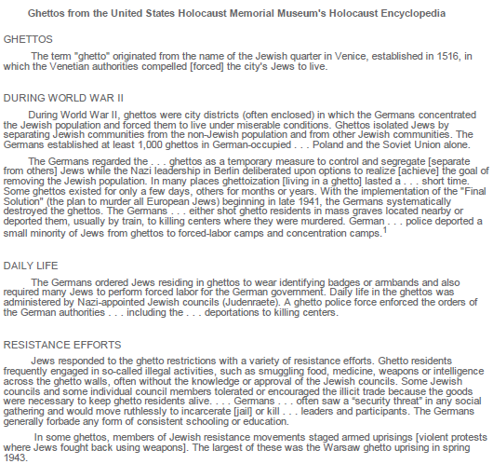
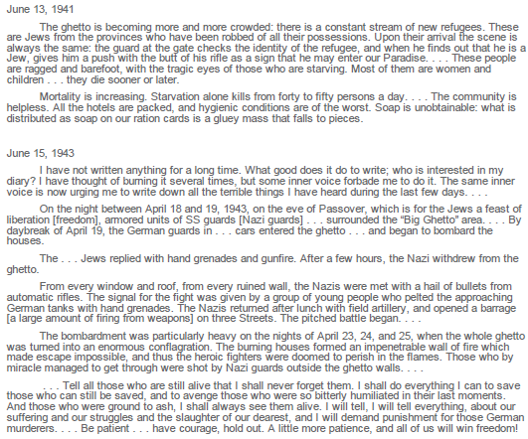
PROMPT
You have learned about ghettos in the Holocaust by reading an informational article, viewing a silent video, and reading a selection of diary entries. In an essay, explain how daily life in a ghetto changed and how Jewish people responded. Be sure to use evidence to compare and contrast how each text portrays different aspects of life in the ghetto.

Student A (SRI: Basic - 891)
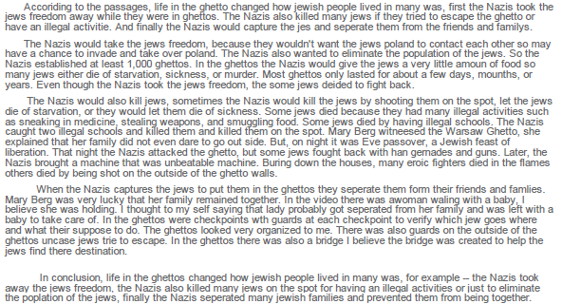
Student B (SRI: Advanced: 1499)
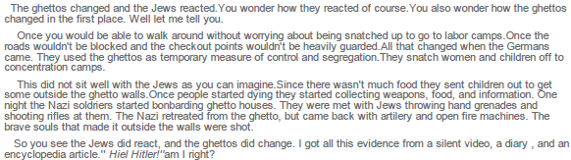
Student C (SRI Proficient: 1116)
Student D (SRI Advanced: 1168)
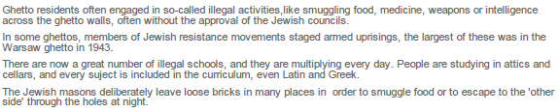
Student E (SRI Basic: 905)
